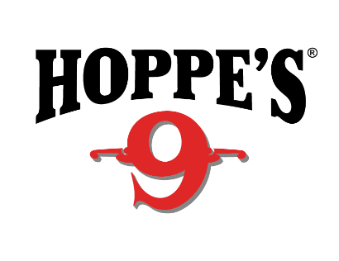 Contact: Kristen Veverka
Communications Manager
Tactical Products & Shooting Accessories
(913) 689-3630
FOR IMMEDIATE RELEASE E-mail: pressroom@vistaoutdoor.com

Hoppe’s Announces New Products for 2018 SHOT Show
OVERLAND PARK, Kansas (January 18, 2018) – Hoppe’s, the best known name in gun care products, will launch new products to dealers at booth 14551 at the 2018 Shooting Hunting and Outdoor Trade (SHOT) Show in Las Vegas, January 23 to 26.

The BoreSnake and BoreSnake Viper Den showcase that the original, fastest bore cleaner on the planet has a new and improved home. The BoreSnake now includes a T-handle for easier pull through of your firearm and a reuseable carrying case that you can keep in your range bag or backpack to protect your BoreSnake during transport. A one pass solution, BoreSnake uses an integrated bronze brush to scrub out carbon fouling, while the tail clears the barrel of loose debris with a surface area 160 times larger than a standard patch. The original BoreSnake is back and better than ever at an MSRP of $16.99-$19.99.
New for 2018, the leader in guncare for over 100 years introduces its first-ever cleaner, lubricant and protectant formula all in one. Hoppe’s BoreSnake CLP is an effective one-step cleaner, lubricant and rust preventative intended for use in all pistol, rifle and shotgun models. Designed to break down and remove carbon, lead and powder fouling, the corrosion inhibitors prevent rust from forming, leaving behind a lasting coat of protection.
Hoppe’s new CLP also provides total protection when used in combination with a Hoppe’s BoreSnake. Apply Hoppe’s CLP to the head of the BoreSnake prior to use to clean, protect and coat the interior of your bore for year-round protection. Available in a 2 oz. squeeze bottle and featuring a pinpoint applicator, this product has an MSRP of $7.99.
Hoppe’s, a Vista Outdoor brand, serves shooters of all disciplines, and offers gun care products that meet the rigorous standards Frank Hoppe established more than 110 years ago. Visit the website at www.hoppes.com.

About Vista Outdoor
Vista Outdoor is a leading global designer, manufacturer and marketer of consumer products in the growing outdoor sports and recreation markets. The company operates in two segments, Shooting Sports and Outdoor Products, and has a portfolio of well-recognized brands that provides consumers with a wide range of performance-driven, high-quality and innovative products for individual outdoor recreational pursuits. Vista Outdoor products are sold at leading retailers and distributors across North America and worldwide. Vista Outdoor is headquartered in Utah and has manufacturing operations and facilities in 13 U.S. States, Canada, Mexico and Puerto Rico along with international customer service, sales and sourcing operations in Asia, Australia, Canada, and Europe. For news and information, visit www.vistaoutdoor.com or follow us on Twitter @VistaOutdoorInc and Facebook at www.facebook.com/vistaoutdoor.

###

